**Literature Review**

|  |  |  |  |  |
| --- | --- | --- | --- | --- |
| **S.no** | **Title** | **Authors** | **Published Date** | **Major Findings** |
| 1. | **A Study of Data Mining Techniques in Glaucoma Detection.** | **R.Gomathi, R.Ramprashath, A.Gokulraja, M.Bharath, K.Sri Hari Vishnu** | **Apr-20** | **1. To prevent the vision loss of the patient early detection of glycoma is very necessary and that can be done by data mining techniques.**  **2. OCT(Optical Coherence Tomography) is an imaging technique that is used for medical imaging and industrial nondestructive testing.** |
| **2** | **Non-Invasive Diagnosis of eye disease using Image segmention and neural networks** | **L.Parvathvarthiny, S.Batmavady** | **05-May-14** | **1. Medical Diagnosis of retinal disease takes long course of time and initially Similar kind of treatment is carried out this leads to vision loss from the retinal images of the region present lesions can be predicted.**  **2. Gabour Filter has DC Component so it perform non-uniform coverage of edge segmentation whereas Log-Gabor filter has No DC component and it perform accurate edge segmentation.** |
| **3** | **A General Regression Neural Network** | **Donald F. Specht** | **06-Nov-91** | **1. The General Regression neural network(GRNN) learns in one pass through the data and can generalize from example as soon as they are stored.**  **2. The main disadvantage of GRNN relative to other technique is that it requires substainial computations to evaluate new points.** |
| **4** | **Artificial Intelligence and deep learning in Ophthalmology** | **Daniel Shu Wei Ting, Louis R Pasquale, Lily Peng, John Peter Campbell, Aaron Y Lee, Rajiv Raman, Gavin Siew Wei Tan, Leopold Schmetterer, Pearse A Keane, Tien Yin wong** | **23-Oct-18** | **1. To improve clinical acceptance of DL Systems it is important to unravel the 'Black Box' nature of DL Using existing and future methodology.** |
| **5** | **Development and Verification of ANN Classifiers for Eye Diseases Diagnosis** | **Hossein Parsaei, Mohammad H Moradi, Roya Parsaei** | **2008** | **1. Artificial Neural Network are able to learn different patterns of visual field loss. In General the result indicates that all these classifiers perform better than the global indices.**  **2. ANN are use for eye disease diagnosis and result validation on Standard automated perimetry data. The ANN in general outperforms the performance of the global indices of STATPAC indices as measured by CCN and PCCN.** |
| **6** | **Promising AI-ML-DL Algorithms in Ophthalmology** | **Lokman Balyen** | **Aug-19** | **1. Automated Retinal Imaging technologies may potentially reduce the barriers to acess to health care systems and health screening.** |
| **7** | **Applications of AI in Ophthalmology: General Overview** | **Wei Lu, Yan Tong, Yue Yu, Yiqiao Xing, Changzheng Chen and Yin Shen** | **19-Nov-18** | **1. Most Studies Regarding intelegent diagnosis focused on binary classification for instance to detect AMD we fail to consider a patient with glaucoma. Choi and his collegues carried out the work applying DL to automatically detect multiple different retinal diseases.**  **2. The High Dependency on the data quality should be considered different imaging device various imaging protocols and intrinsic noise of data can affect data's quality which may have huge influences on model performance.** |
| **8** | **The Research of regression model in machine learning field** | **Shen Rong, Zhang Bao-wen** | **2018** | **1. The paper herein introduce a linear regression model used to analyze the sale of iced product of the company** |
| **9** | **The Investigation of the level of preschool children with eye sights problem functional state** | **Sedava O.O** | **03-April-2003** | **1. Pre school childrens with vision problems functional state with respect to their sex it was found that boy's indicators are improving coinciding age.**  **2. Initial data of preschool children with vision problems age dynamic of their functional state permitted to establish that these indicators are improving, coinciding age.** |
| **10** | **Spectrum of Visual impairment among female school students of Surat** | **Mausumi Basu, Palash Das, Ranbir Pal, Sumit Kar, Vikas K Desai, Abhay Kawishwar** | **Dec-11** | **1. Out of 3002 children, 457 (15.22 %) had defective vision. Myopia affected 418 (91.47%) students while hyperopia was observed in 21 (4.60%) students; astigmatism was present in 18 (0.04%). The prevalence of myopia in the total number of participants was 13.93%. The prevalence of myopia and astigmatism was more in higher age groups, while hyperopia was more in lower age groups;** |
| **11** | **The Prevalence of Eyesight Deterioration in people aged over 50 years and it correlation with Type II Diabetes in trinidad** | **B. Shivnanda Nayak** | **Sep-19** | **1. This study determined that there is, to an extent, a correlation between the incidence of eyesight deterioration and type II diabetes in people aged over 50 years.** |
| **12** | **Physical inactivity in relation to self-rated eye sight** | **Lee Smith, Matthew A Timmis, Shahina Pardhan, Keziah Latham, James Johnstone, Mark Hame** | **01-Dec-16** | **1. A total of 16.2%, 35.6%, 37.7% and 10.6% of the sample rated their eyesight as excellent, very good, good and fair poor, respectively. Those with fair–poor self-rated eyesight were older (mean 67.8 years) and more likely to be female (59.6%)** |

**Results after Literature Review: -**

**After Reviewing all the Literature we’ve come to a conclusion that there has to be a system which can predict your lens power by just answering some basic questions. Without the help of refractometer, we can find an approximate lens power.**

**There are Many algorithms to detect glaucoma, AMD or other retinal disease but there are no algorithms to detect eyesight problems. There are not enough eye care centres in rural regions and the instruments to get the approximate lens number are also very costly so, after thinking about all these points we came to a conclusion that there has to be an AI system that can predict the lens power.**

**INTRODUCTION**

**People from both rural and urban area suffers from eye sight problems based on their age, sex etc. Vision problems (Hyperopia and myopia) will damage the optic nerve and also leads to more vision loss. If a person doesn’t take proper initiative then it may cause serious vision loss in early ages or even blindness in some serious cases.**

Nearsightedness (**Myopia**) is a common vision condition in which you can see objects near to you clearly, but objects farther away are blurry. It occurs when the shape of your eye causes light rays to bend (refract) incorrectly, focusing images in front of your retina instead of on your retina. Nearsightedness may develop gradually or rapidly, often worsening during childhood and adolescence. Nearsightedness tends to run in families.

Hyperopia (farsightedness), is a refractive error, which means that the eye does not bend or refract light properly to a single focus to see images clearly. In hyperopia, distant objects look somewhat clear, but close objects appear more blurred. People experience hyperopia differently. Some people may not notice any problems with their vision, especially when they are young. For people with significant hyperopia, vision can be blurry for objects at any distance, near or far. It is an eye focusing disorder.

Presbyopia is the gradual loss of your eyes' ability to focus on nearby objects. It's a natural, often annoying part of aging. Presbyopia usually becomes noticeable in your early to mid-40s and continues to worsen until around age 65. You may become aware of presbyopia when you start holding books and newspapers at arm's length to be able to read them. A basic eye exam can confirm presbyopia. You can correct the condition with eyeglasses or contact lenses. You might also consider surgery.

**DATA COLLECTION**

**A Large amount of composite data from eye clinics like their vision details without spectacles, general details about their condition like headache or eye strain etc. Data collection is one the major task. We’ve also collected their eyesight numbers (Lens Powers).**

**DATA PREPROCESSING**

After collecting all the data we’ve performed the following operations.

**Importing the Libraries**

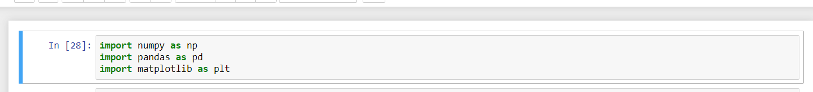

**After importing Libraries ,separate the data into Left eye data and Right Eye data**

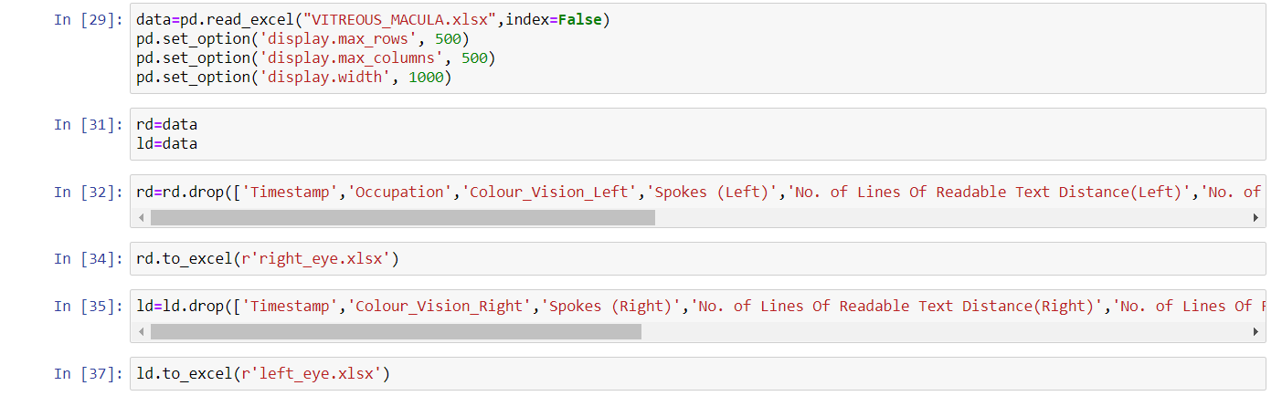

**Pre-processing of Left Eye Data by down casting from String to Float**

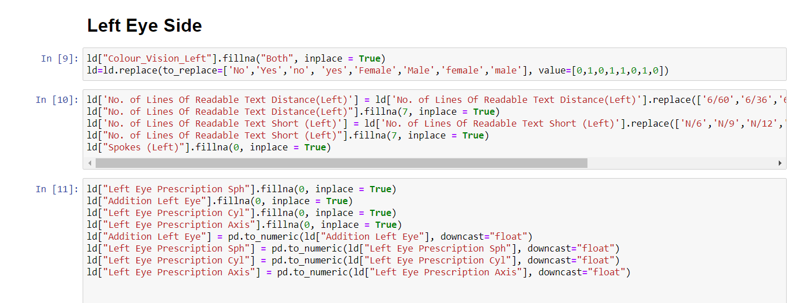

**Using One Hot Encoder for Encoding Categorical Data and Saving back in data frame**

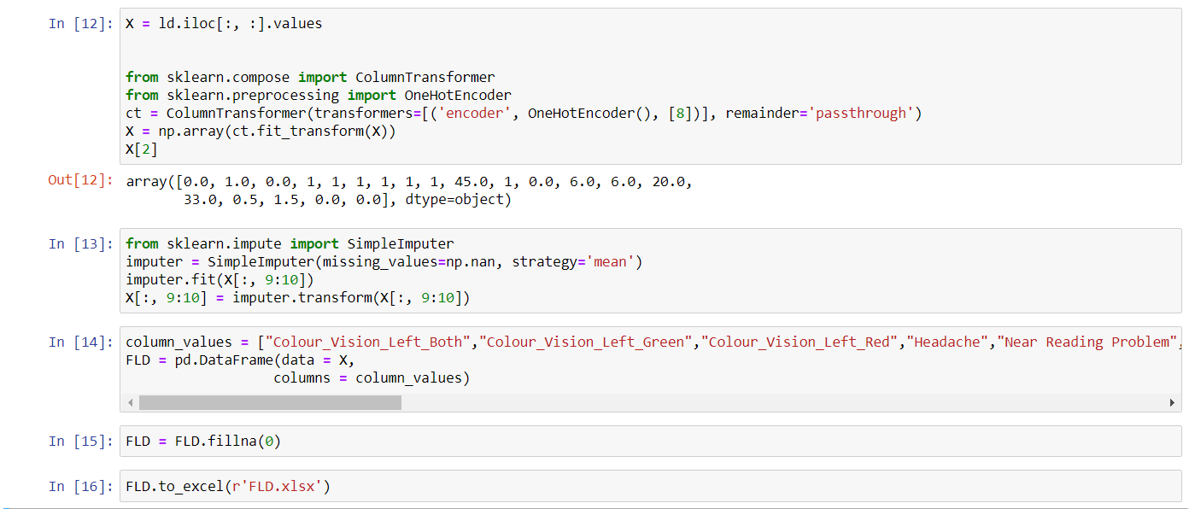

**Doing the same with Right eye data**

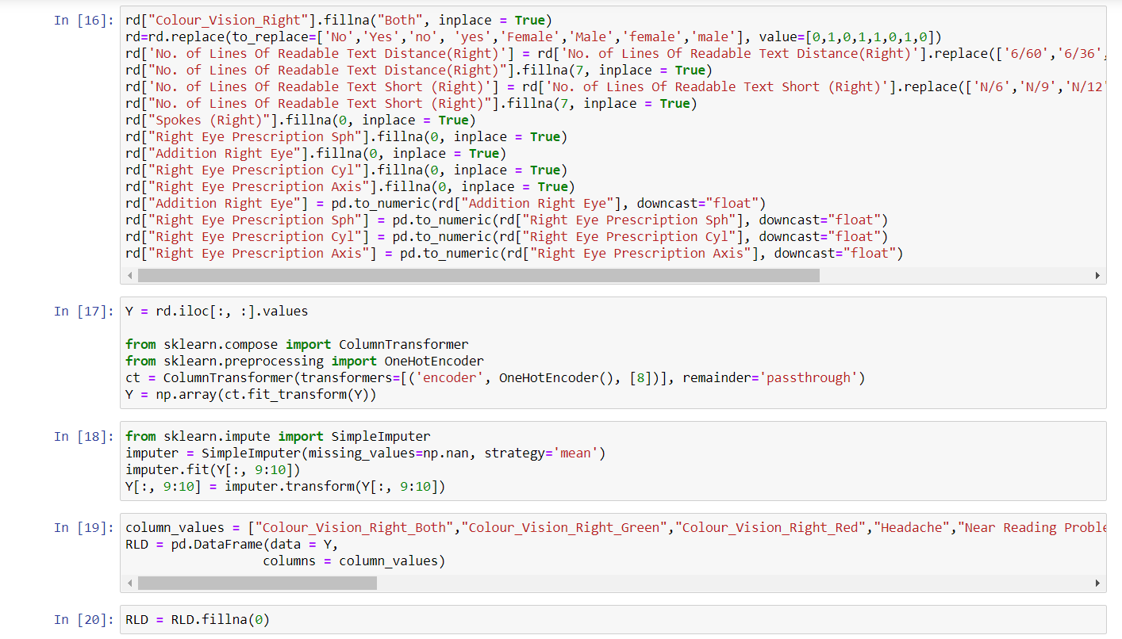

**MODEL FOR AXIS**

After pre-processing of data next step is to make a DL model for axis prediction.

The model for axis is as follow: -

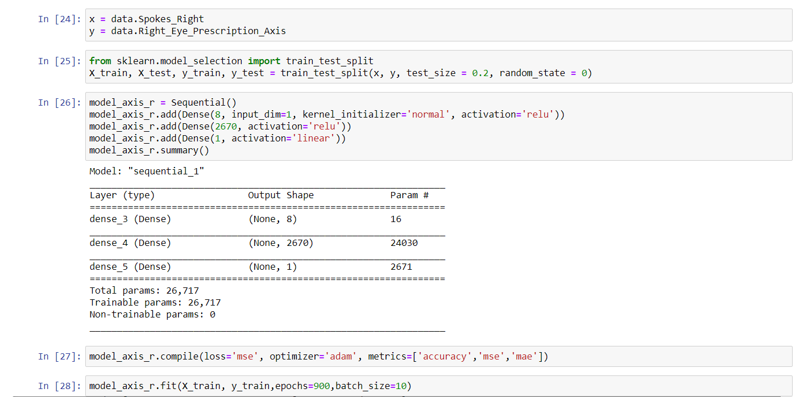

**MODEL FOR SPHERICAL POWER**

After axis next, we make a model for spherical power prediction.

The model for spherical power is as follow: -



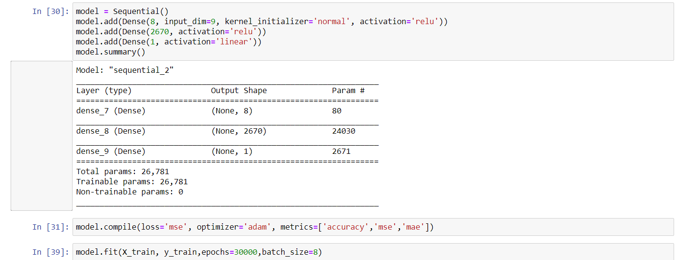

**MODEL FOR CYLENDRICAL POWER**

After spherical power next step is to create a model for cylindrical power prediction.

The model for cylindrical power is as follow: -

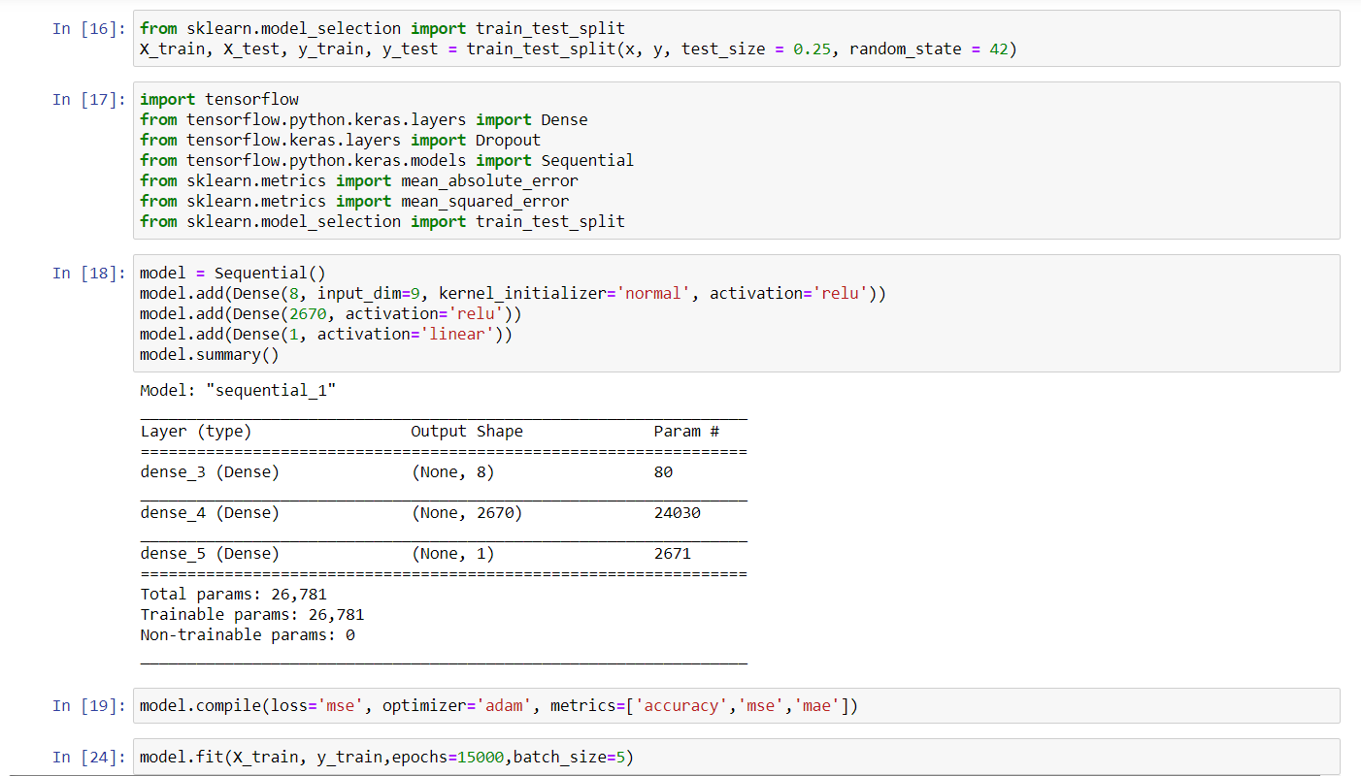

**MODEL FOR ADDITION POWER(PRESBIOPIA)**

After cylindrical power next step is to create a model for addition power.

The model for addition power is as follow: -

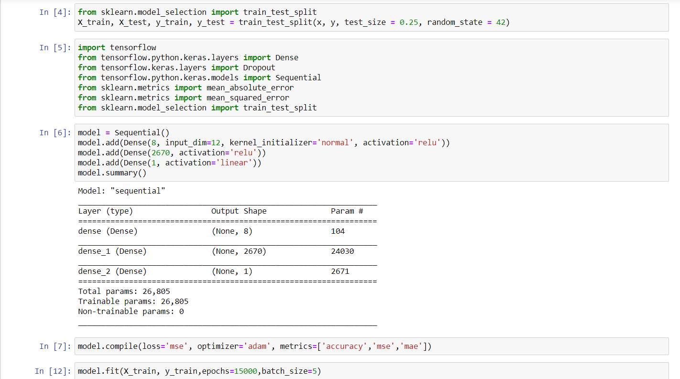

**INPUTS FOR MODELS**

There are different inputs for all models the models and their inputs are as follow: -

**FOR AXIS MODEL**



**FOR SPHERICAL MODEL**



**FOR CYLENDRICAL MODEL**



**FOR ADDITION MODEL**



**RESULTS**

When we test that model with random peoples the following result came out: -

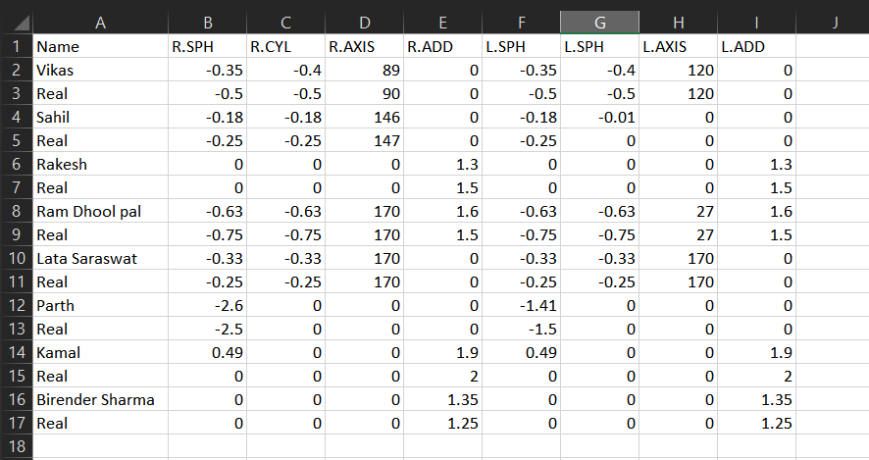

**ACCURACY GRAPH: -**

**SPHERICAL MODEL**

**CYLENDRICAL MODEL**

**AXIS MODEL**

**ADDITION MODEL**

**CONCLUSION**

To prevent the vison loss or serious vision problem of the patient early detection of myopia, hyperopia and presbyopia is very necessary in healthcare department. Our Web application is a part of DL application has been increased with the accuracy of predicting disease give more importance to these techniques. DL techniques in the existing are to detect the disease as earlier so it will avoid vision blindness. From the mentioned attribute can conclude that a person can affect or affected or how much affected by these diseases or not. Using data and Deep Learning with effective results is major advantage to predict vision disease in early stage to reduce the chance of risky level.